Practical 5

**Aim:** Matrix Multiplication Application using Python and MapReduce

Check the current working directory and changing the current working directory to the folder matrix

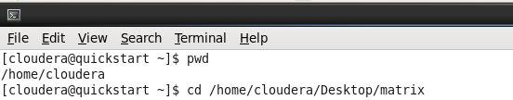

**Step 1:** Create 2 matrix text files with shape 2x3 and 3x2 in a folder(Here we name the folder as matrix)

**Matrix 1:**

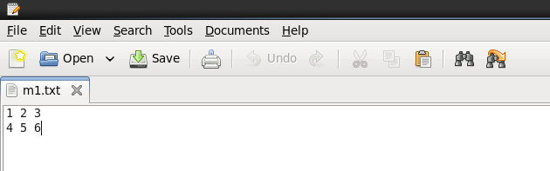

**Matrix 2:**

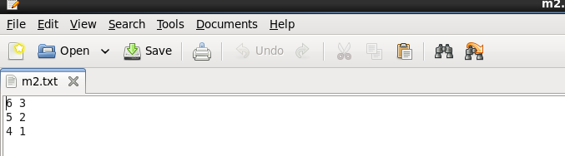

**Step 2:** Now create a mapper function in python and save it in the same folder as the matrix text files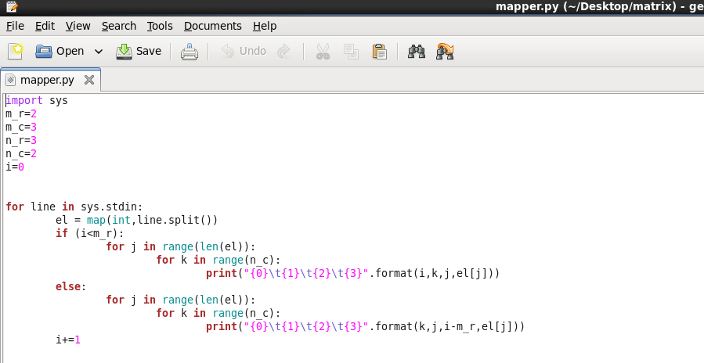

**Step 3:** Create a reducer function in python and save it in the same matrix folder

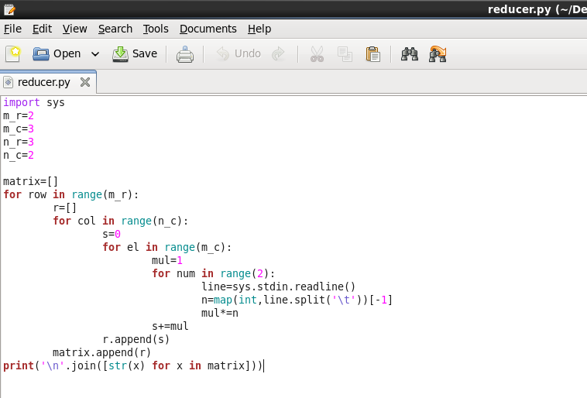

**Step 4:** Checking the output of the mapper.py function

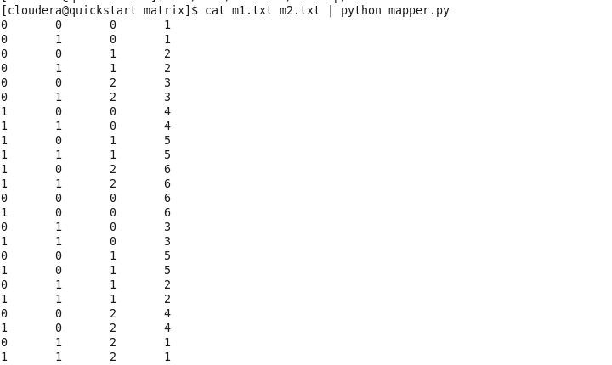

**Step 5**: On running the mapper and reducer function together along with the 2 matrix we get

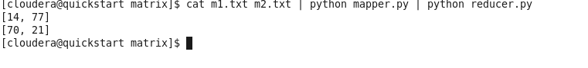

**Conclusion:**

[14,77]

[70,21]

This is the following output of matrix multiplication